SPRINT-3

|  |  |
| --- | --- |
| **TEAM ID** | PNT2022TMID07793 |
| **PROJECT TITLE** | REAL-TIME RIVER WATER QUALITY MONITORING AND CONTROL SYSTEM |
| **DATE** | 13 NOVEMBER 2022 |
| **MAXIMUM MARK** |  |

PYTHON CODE:

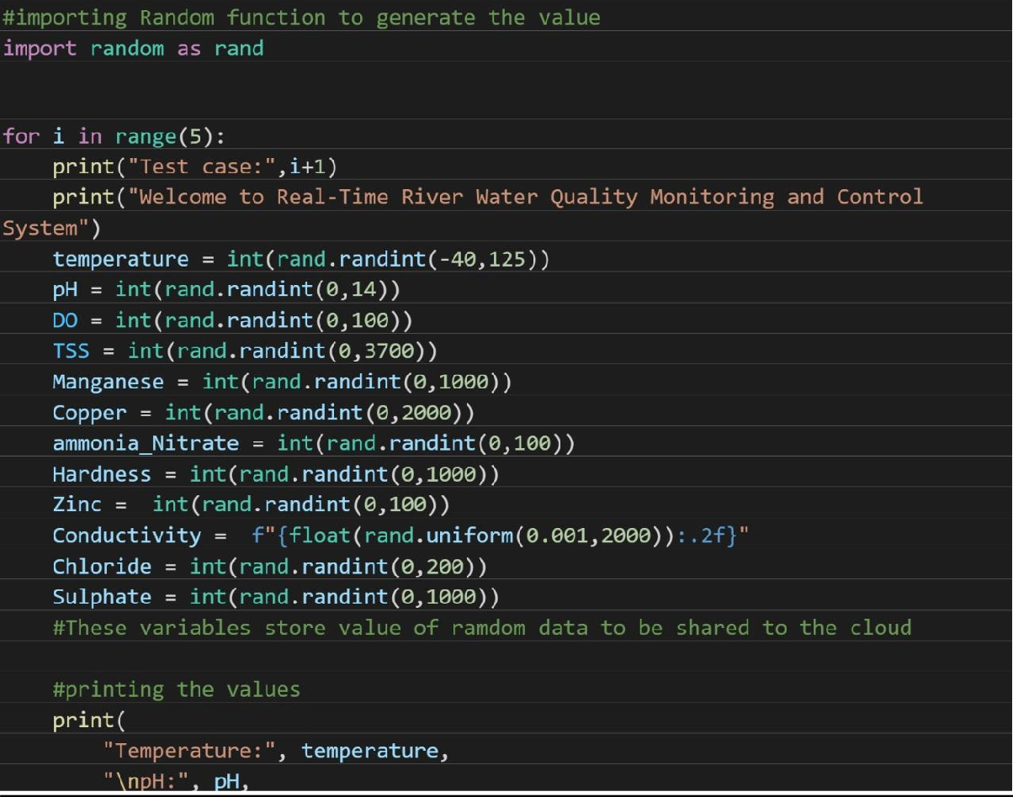

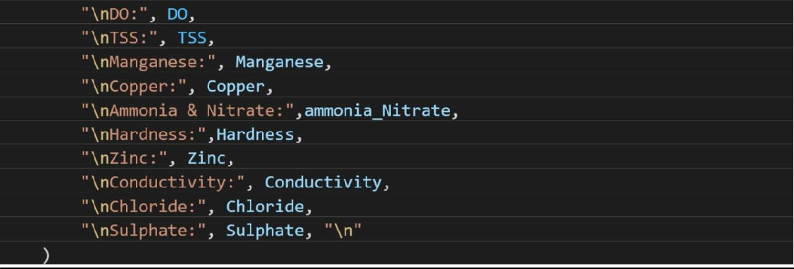

PYTHON OUTPUT:

